Curnow School
Post 16 Offer
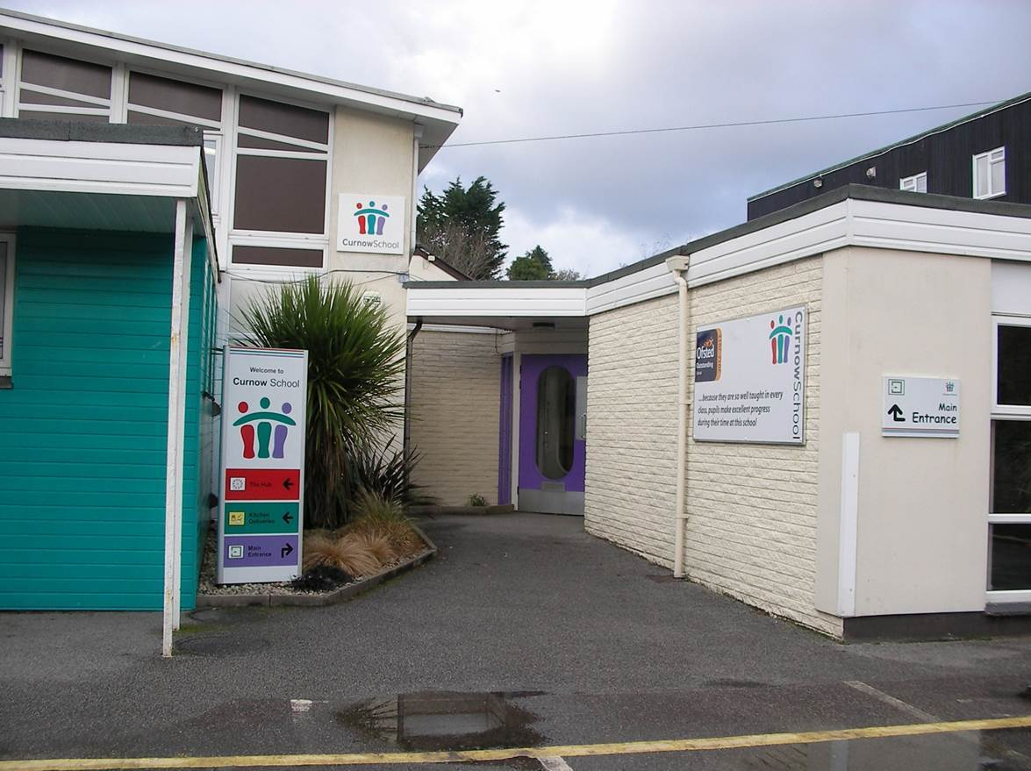

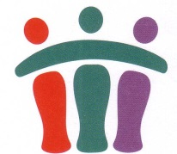


This booklet is intended to help parents and carers understand what we achieve in the Post 16 provision at our school.

In this booklet you will find information about the following –

- Welcome to our school.

- What do we learn in Post 16?

- The core areas of the Post 16 Curriculum.

- The Preparing for Adulthood areas of the Post 16 Curriculum.

- Community links.

- Working in partnership with parents.

- Key staff and contact details.

Our School.
Welcome to Curnow School.
We are a special school with a primary site in Illogan and a secondary site in Redruth for pupils aged 2-19.
Our school is a member of the Special Partnership Trust (SPT).
This booklet is an introduction to our Post 16 provision and will provide you with the information you need in relation to our Post 16 offer.
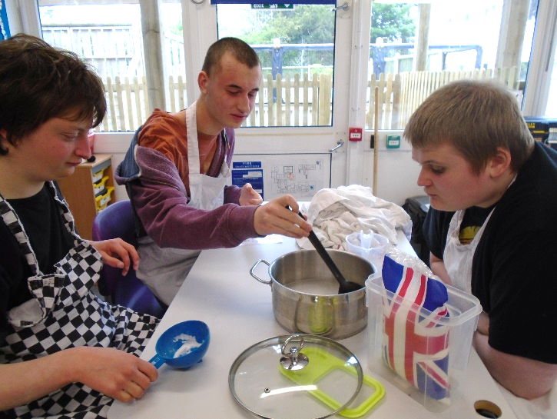

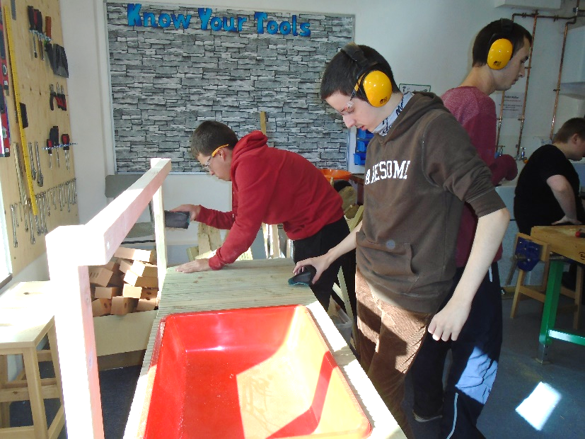

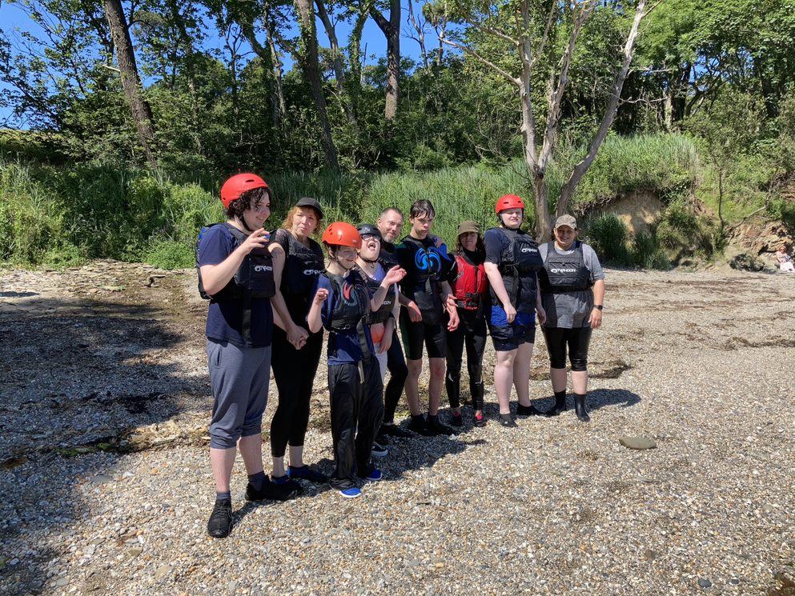

If you would like any further information please visit our school web site www.curnow.cornwall.sch.uk
Families are welcome to come and visit school; please make an appointment by contacting the school and talking to our home- school liaison, Claire Pearne who can be contacted on cpearne@curnowschool.org.uk or by calling the school on 01209 215432
Welcome to our Post 16 provision. Most young people who join our Post 16 provision have moved through the school and for them, this forms the last part of their educational journey at Curnow School before taking their next steps in education, training or employment. However, we do offer places to young people outside of Curnow school if, the provision is felt to be right for their continued development, progress and preparation for adulthood. The local authority will name our school in your child’s Education, Health and Care Plan.
- We hold open days/events in the autumn term to showcase our offer which both parents and students can attend to get an idea of the provisions and meet key people within the team
- We are able to offer visits if the young person/parents would like to see what goes on during the school day within our Post 16 provision.
- We will work closely with your child’s current school if they are moving from another school within the trust or from a school outside of the trust to ensure we can build upon their learning and current progress.
- We have strong links between our Key Stage 4 and Post 16 classes to ensure that our curriculum is preparing young people well for what they will be learning within our Post 16 offer
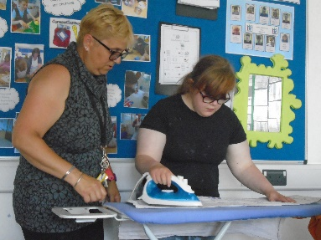
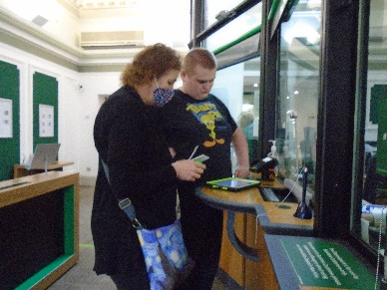
- We work closely with all the different Post 19 providers to ensure that our students are ready and prepared for their next step in education, training or employment.

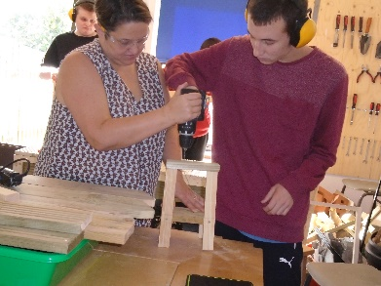

We are always happy to answer any questions you may have in regards to your child's placement at Curnow school; please speak to Claire Pearne, Family Liaison Officer.

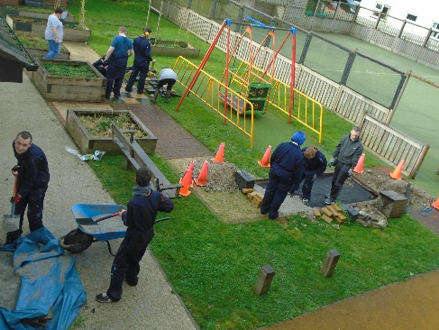
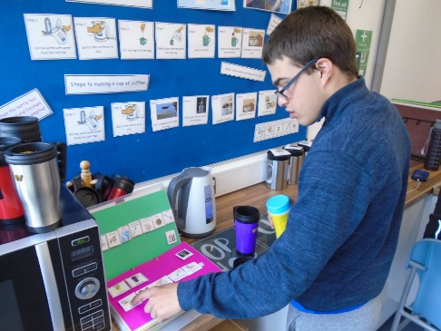
What do the young people learn in our Post 16 provision?
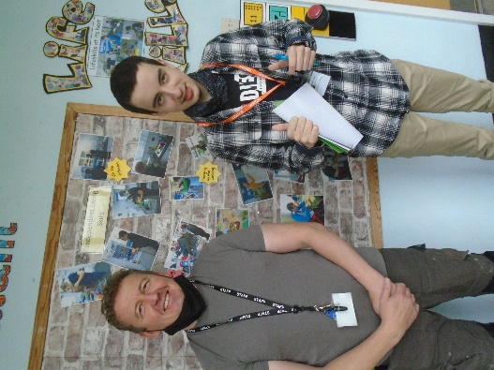 | All Post 16 classes within the SPT offer the Preparing for Adulthood curriculum. This allows us to meet the learning needs of our young people to ensure that we not only continue to develop and embed new skills but that we develop students’ abilities to use and apply skills in wider contexts and f ensure that we are preparing them well for their next step towards adult life.

Our curriculum focuses upon the 2 core areas of learning:

Functional Maths

Functional English

We additionally deliver the three Preparing for Adulthood areas:

Work Related Learning (Including careers education information advice and guidance)

Independent Living and Life skills

Health wellbeing and relationships

The core areas of the Post 16 curriculum.

The core areas of the curriculum support the continued development of your child’s English and math skills with the focus on the application and use of these skills within functional and practical contexts and settings. It is imperative that students are able to use and apply the skills learnt within everyday living activities outside of the classroom setting.

Mathematics

This area of the curriculum is broken down into the following sub areas –Context for number, measure, shape and space and handling data.
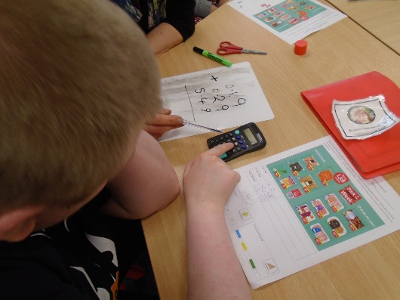

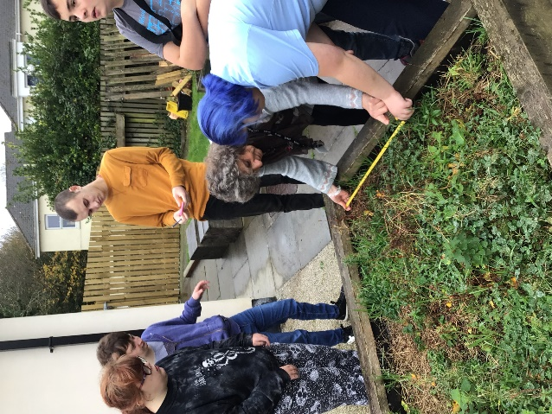

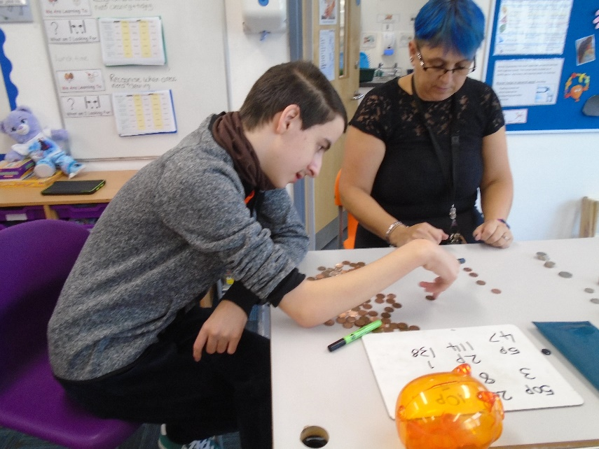

This area will be a major focus area for all our students with core skill sessions each day within class, whereby students are learning new skills that will be embedded, used and applied throughout the rest of the school week within practical and functional learning sessions. Maths is used within all areas of the curriculum and opportunities outside of the classroom such as using money when shopping, or measurement when working in the school garden
Literacy

This area of the curriculum is broken down into the following sub areas – Speaking and listening, reading and writing.
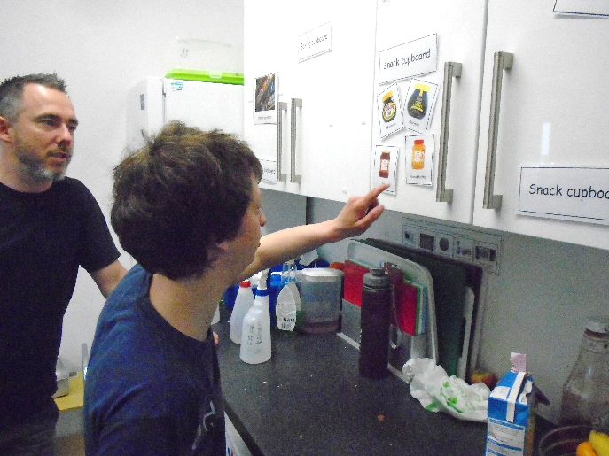

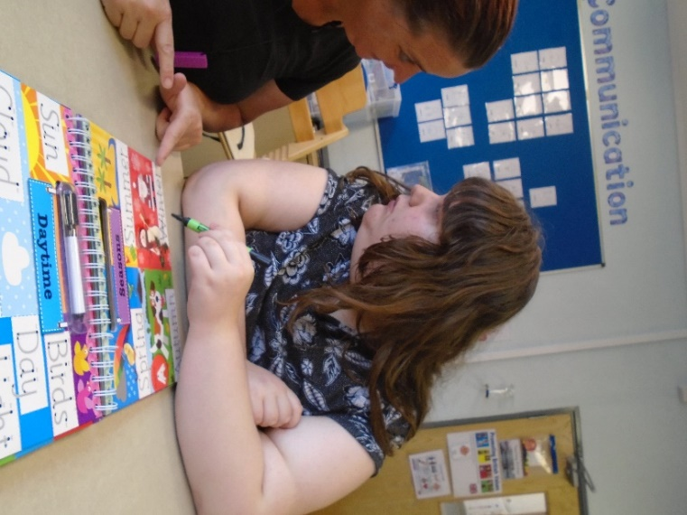

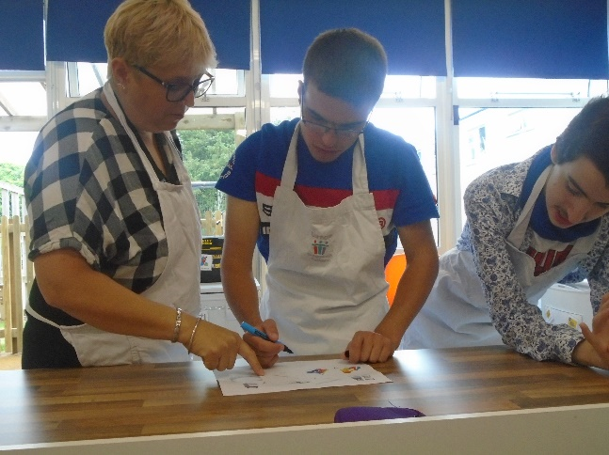

Again this will be delivered within core sessions at the start of each day as well as woven throughout the day via our preparing for adulthood curriculum areas. It is important that students can use their writing or reading skills within activities that will be meaningful within their adult life such as writing a shopping list (this could be with pictures or symbols) or reading a recipe or set of simple instructions to complete a task.
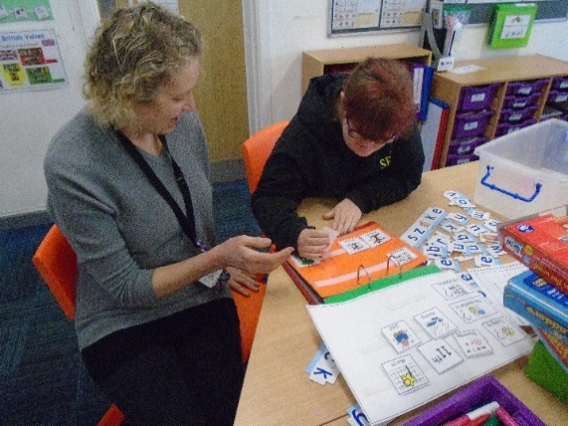
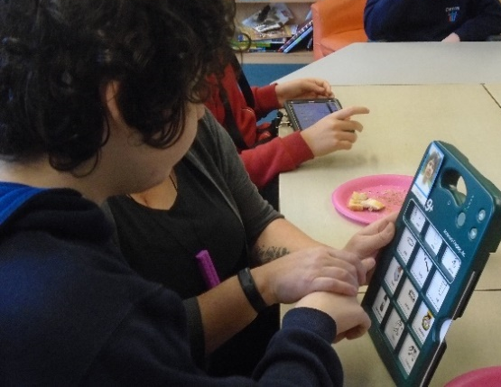
We continue to use a variety of communication approaches but will support your child via their preferred method of communication such as PECS, Makaton signing, objects of reference or use of an AAC device. It is important that every pupil has a voice and can express clear preferences, likes/dislikes and initiate conversation to share their experiences and interests.

We use any advice and guidance received from members of multi-agency teams, such as Speech and Language Therapists, when they are involved with your child.

The Preparing for Adulthood areas of the Post 16 Curriculum.

The Preparing for adulthood curriculum is made up of three strands: Work related learning, Independence and life skills and Health, wellbeing and relationships. These three strands build on previous learning and look to promote the development of functional skills through the practical using and applying within different contexts and environments.

Work Related Learning (including careers education, information, advice and guidance)

This area of the curriculum is broken down into the following sub areas –
1.World of work
2.Pathways to work
3.Business and Enterprise for work*
4.Practical skills for work
5.Skills for work
6.Safety at work
7.Preparing for work
8.My world of work experience
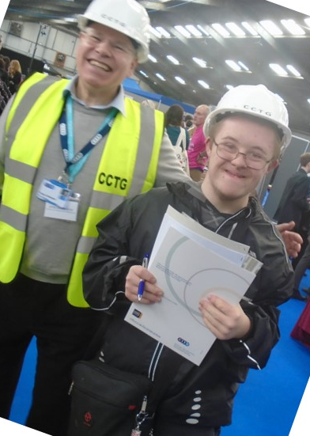
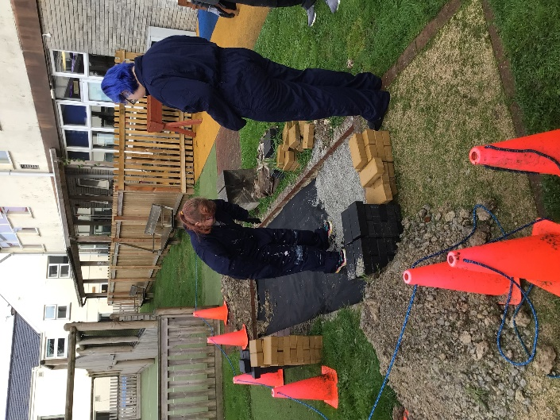

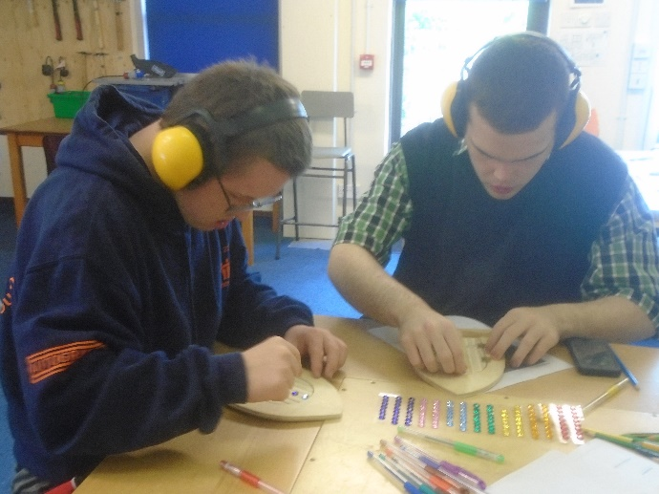
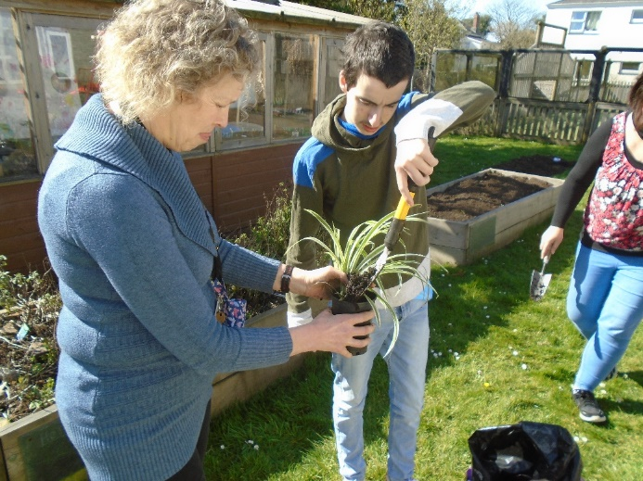

Teaching activities in this curriculum area provide young people with the opportunities to learn about work, learn through work and learn for work. It provides them with opportunities to try different jobs and tasks whilst providing them with time to make decisions and show preferences about their likes and dislikes. Over time this provides a clearer picture of their skills, level of independence and interest within the world of work. We also realise that some of our pupils will not access the formal world of work but are still developing skills such as engagement, communication and choice making which this area of the curriculum can support in a practical and functional way.

Independent Living and life skills
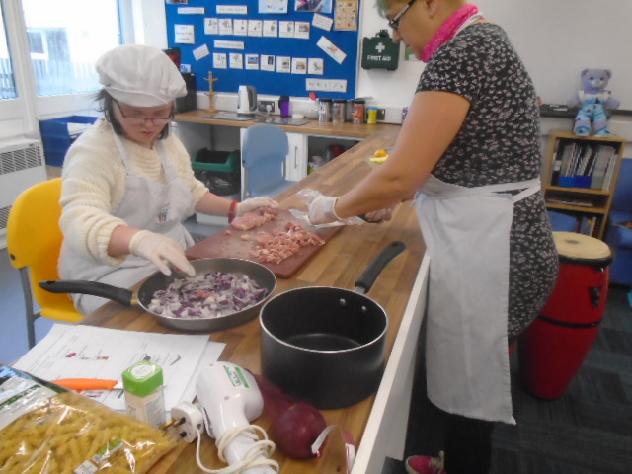
This area of the curriculum is broken down into the following sub areas
1. Looking after the home
2. Looking after the outside
3. Preparing and cooking food and drinks
4. Running an enterprise
5. Travel independence
6. Using local services

Teaching activities look to support and develop each student’s independence and life skills at a level that is meaningful and purposeful to them. This could include helping to make snacks, being able to make clear choices and show preferences or being able to travel more independently within their local community.
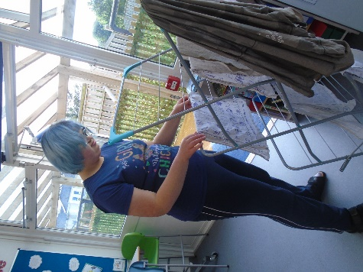
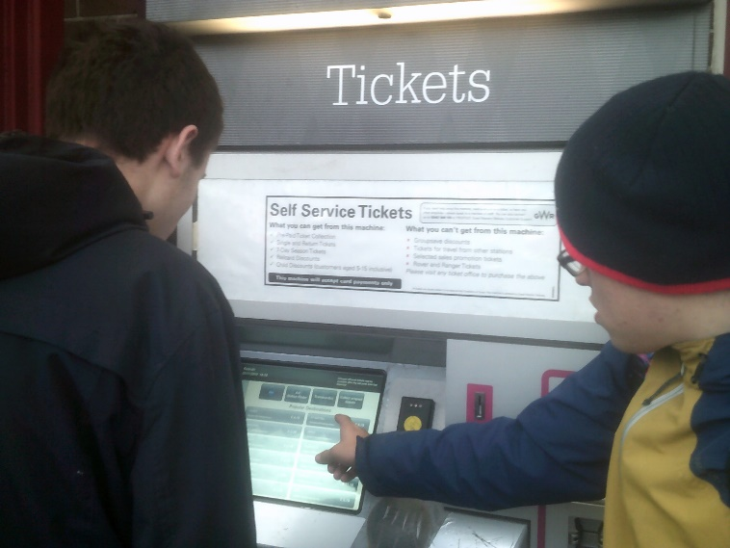

Included in this area of the curriculum is art, design, music, dance and role play. Sensory exploration has vital links to the development of skills in other areas including mark making and food tolerances.
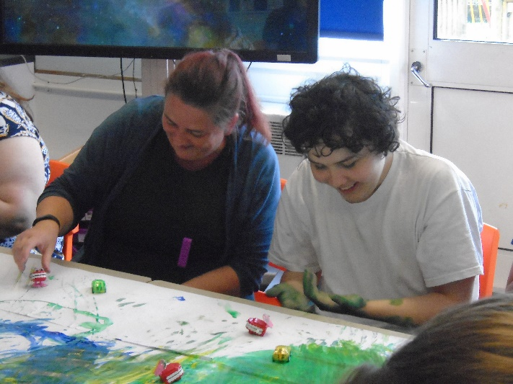
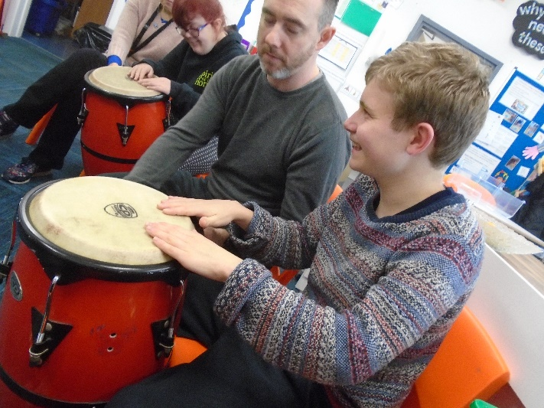

Health, wellbeing and relationships

This area of the curriculum is broken down into the following sub areas –
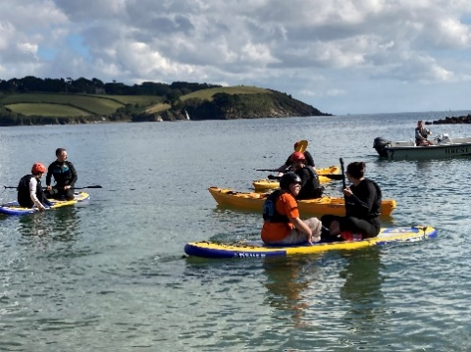
1.Keeping Healthy 4 Life
2.Relationships 4 Life
3.Exploring Personal Interests 4 Life
4.Religion 4 Life

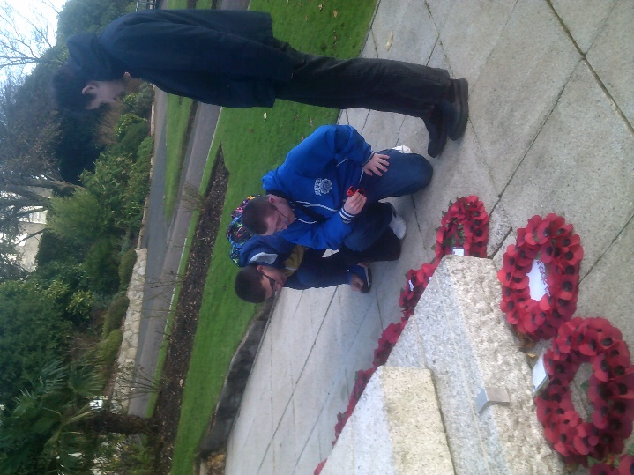

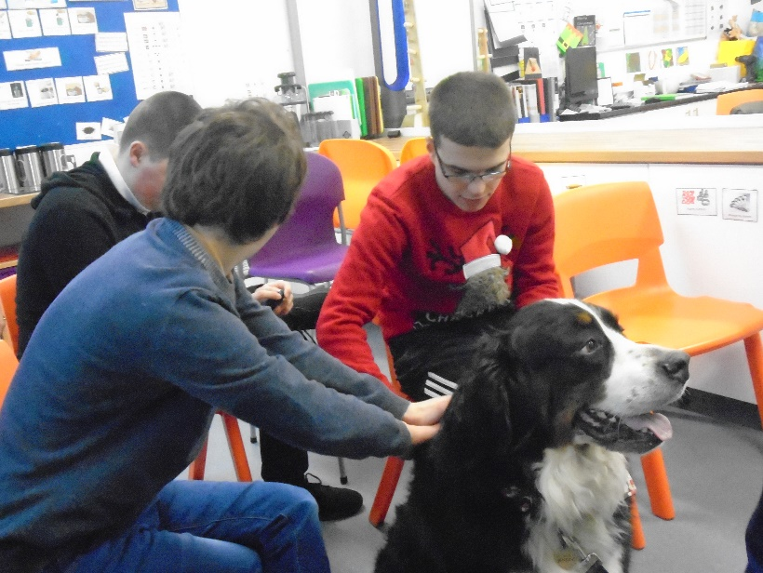

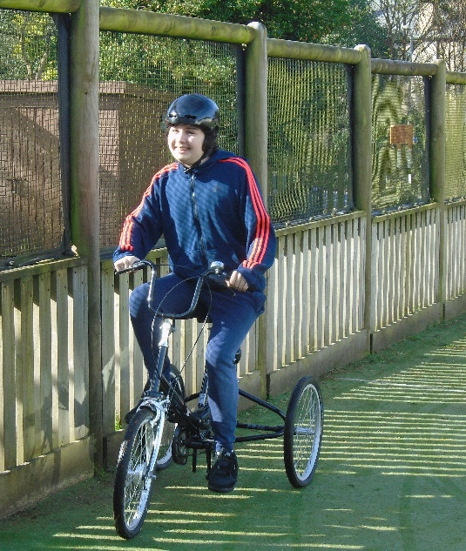
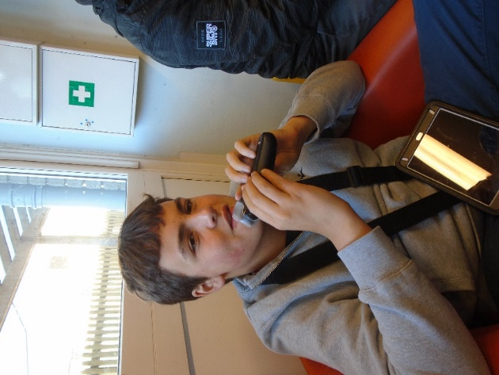

These areas focus on both physical and mental health, the understanding of relationships and the forming of postive relationships. It also includes the development and on going support of individuals interests ensuring that these are supported and encouraged. We also look at religion and the culture and lifestuyles of other people and communities around the world. This is a key area supporting our pupils into adult life and how to keep fit, healthy and lead a postive and fulfilled life.
Using and applying skills in the community and in different contexts.
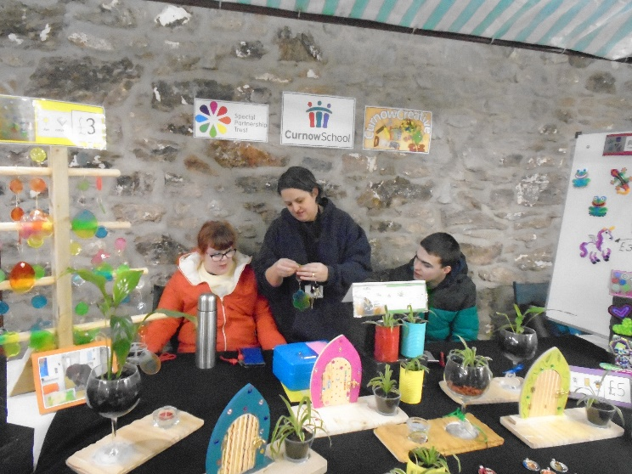

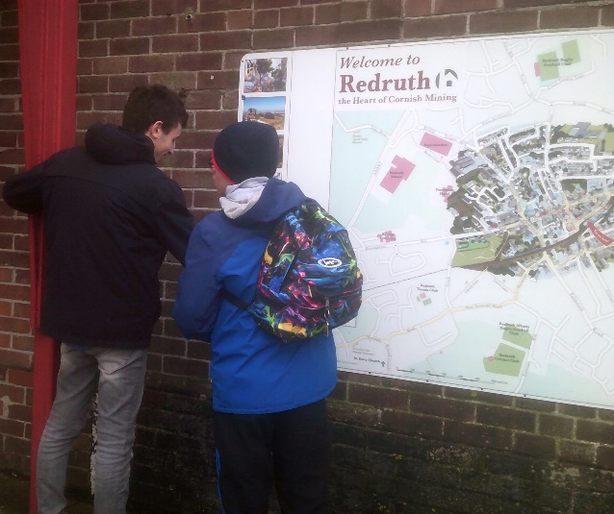

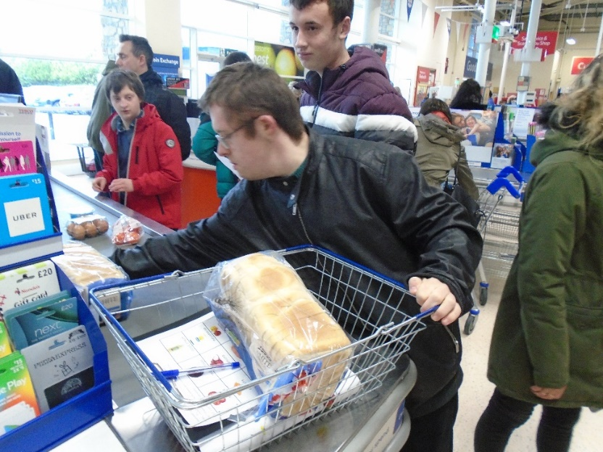

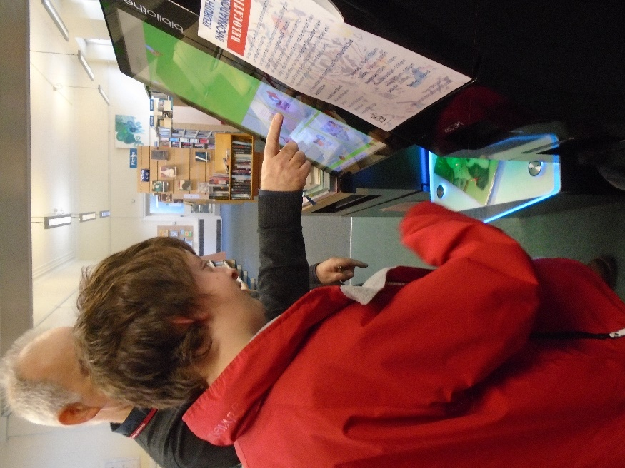

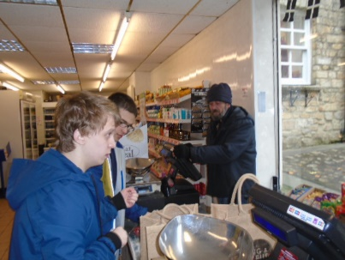

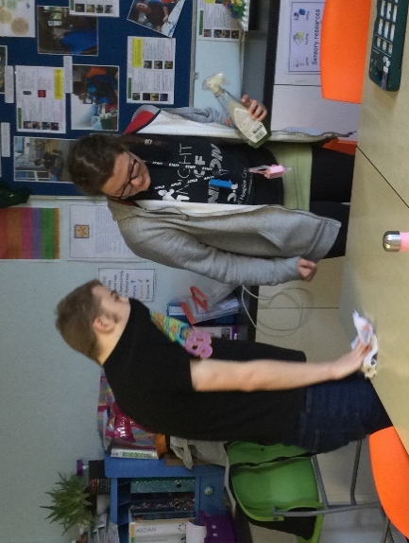
Promoting independence through a functional curriculum.
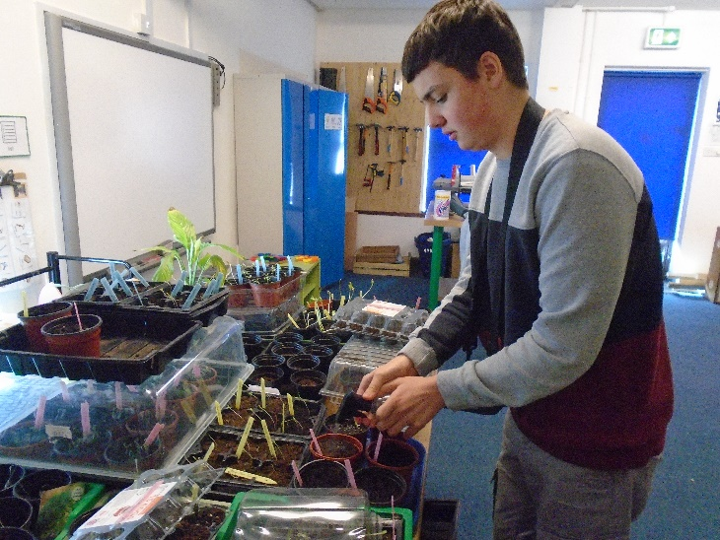

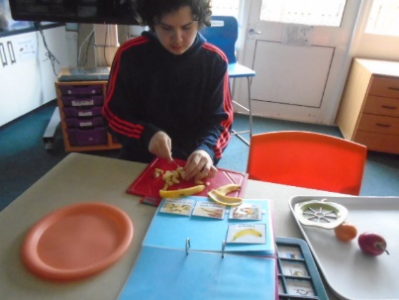
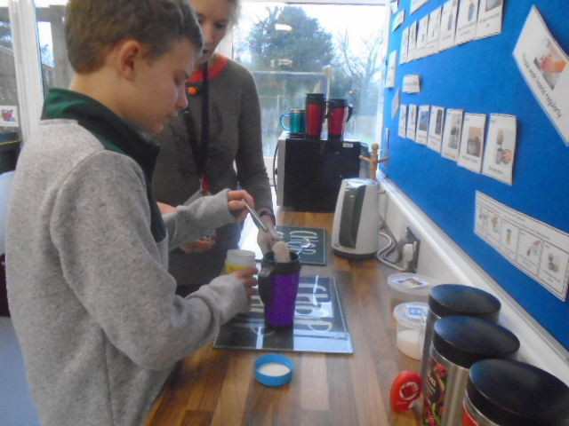

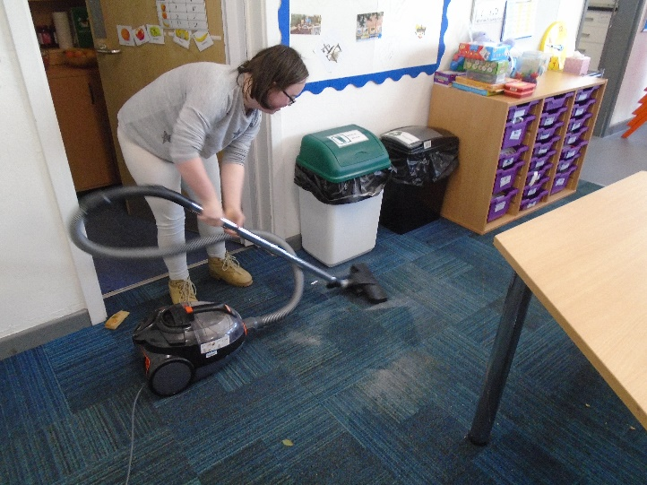

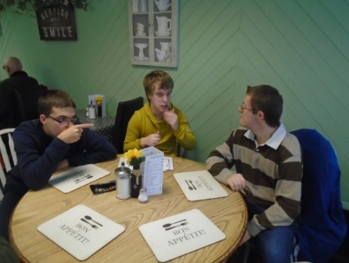
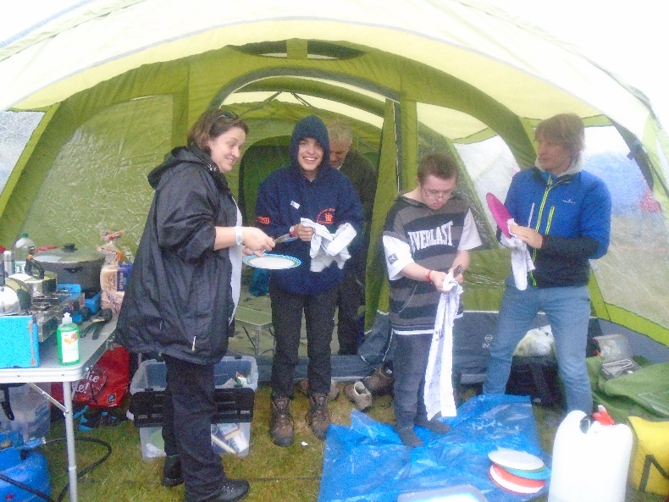
Preparing young people for their next steps.

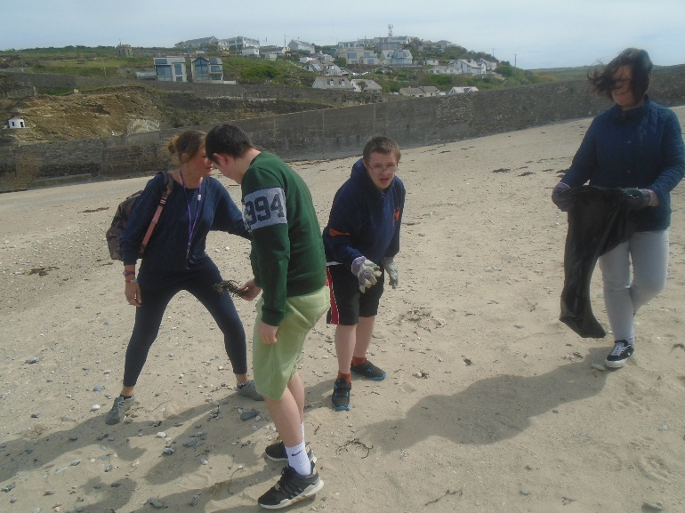
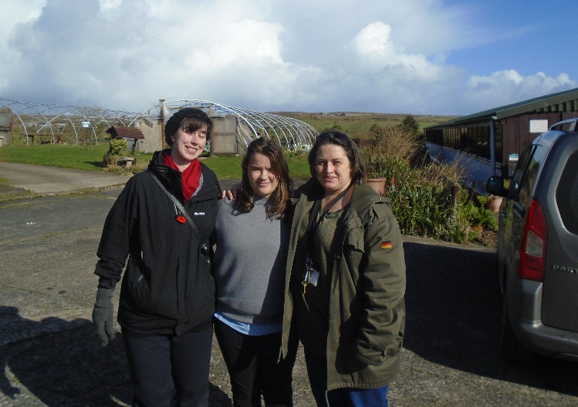

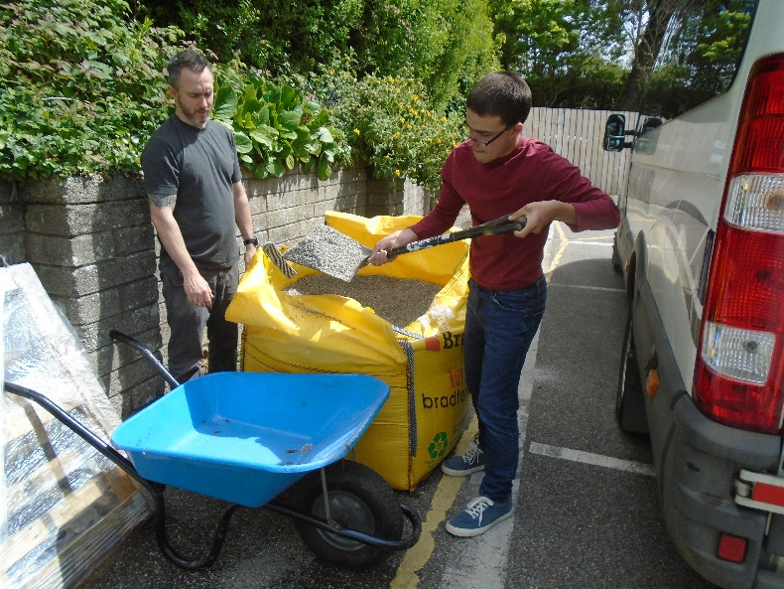
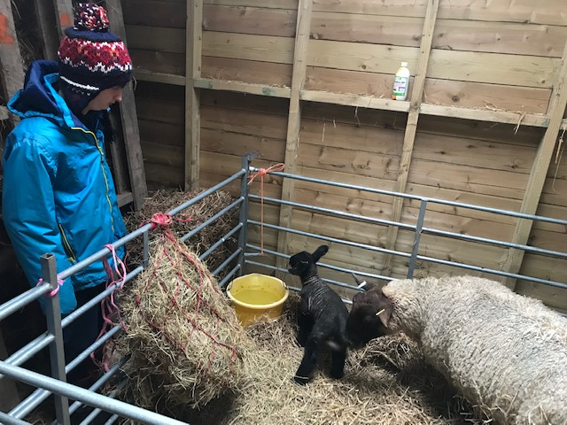


Learning environments and community inclusion

It is important that the teaching environments within Post 16 are different from the rest of the school, more functional and support our aims of preparing students for adult life. With this in mind not only do we have a teaching classroom but have also developed a teaching kitchen and bedroom area (life skills development), a fully functioning workshop, a gym and an outside environment including space for horticulture and gardening.
It is also very important that learning can happen outside of the classroom and within the local community where we have developed many links such as with the local colleges, Post 19 providers, local business and links to local events where we can make a positive impact within the local community.

Working in partnership with parents.
Our partnership with you and your family is vital in allowing us to secure the very best outcomes for your child while they are in our school. We will send home a daily diary to ensure that you know what your child has learned each day and we will respect your wishes to provide any other information that is important to you, for example information about your child’s interests, wellbeing and behaviour throughout the day.

Throughout the year we will invite you in to school for specific events such as our Post 16 open evening and Post 19 event where you can find out more information and seek advice and guidance about post school options.
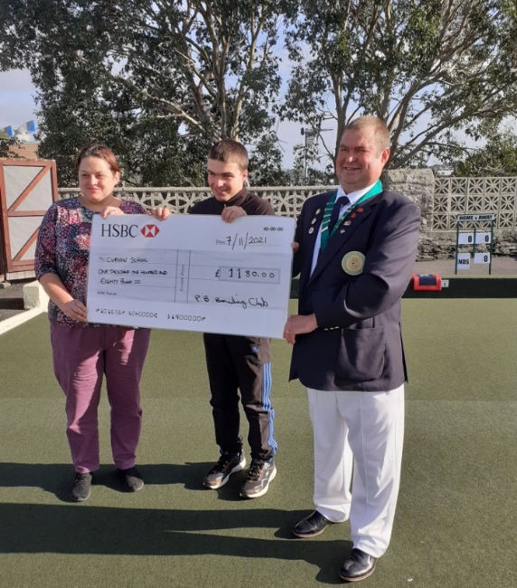
You will be invited to termly parent progress meetings and these meetings will also be an opportunity to support us in setting challenging and appropriate IEP targets. Your input into the Education, Health and Care Plan meeting is vital in ensuring that the plan continues to accurately reflect your child’s strengths, areas of needs and to set targets that will guide us in providing the best quality educational experience.
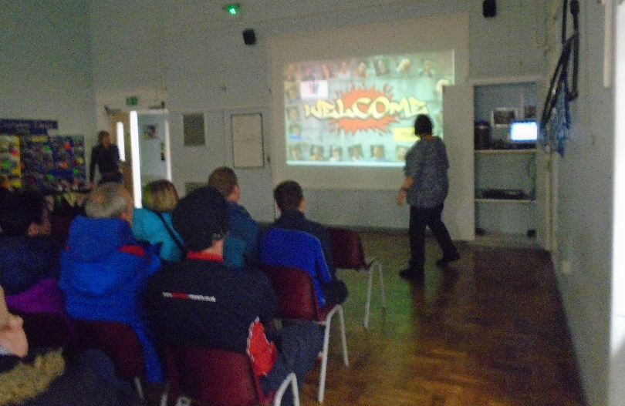

Key staff and contact details.


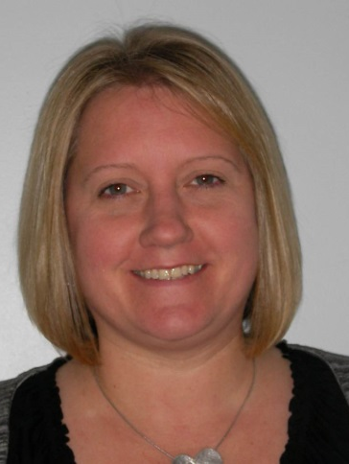


Chriselle Bishop
Post 16 Lead
cbishop@curnowschool.org.uk

Claire Pearne
Family liaison
cpearne@curnowschool.org.uk

Rob Armstrong
Deputy Headteacher
rarmstrong@curnowschool.org.uk

Curnow Upper School,
Drump Road
Redruth
TR15 1LU 01209 215432


