Welcome to Post 16…and beyond!

We would like to take this opportunity to share some important information to help support your and your child's journey in Post 16. Three years seems like a long time, but in the world of Post 16 this time will pass by quickly. Thus, we wanted to share some suggested timelines and key action points that might prove useful to prepare for the deadline that happens in the summer term of Year 13 – choosing Post 19 provision. We appreciate how apprehensive a Post 19 transition can be, which is why along with the guide below, we have also developed a ‘Post 16 and Beyond’ information page on our website. Here, links to Post 19 providers can be found along with the contact details for Careers Southwest, who support transitions to Post 19 placements. As always, please contact me on ddockery@curnowschool.org.uk if you have any queries or concerns about any of the information below.

Dee
 | Autumn Term | Spring Term | Summer Term
Year 1 (Y12) | Get Settled:  Get to know the Post 16 Team, Staff, & Peers.  Get used to how we do things in Post 16 such as our timetables that include new and different learning opportunities including our ‘experiences of’  Post 19 settings that we provide as and when we can throughout the three years of Post 16. | Start to explore:  What is out there? – look on Cornwall Opportunities  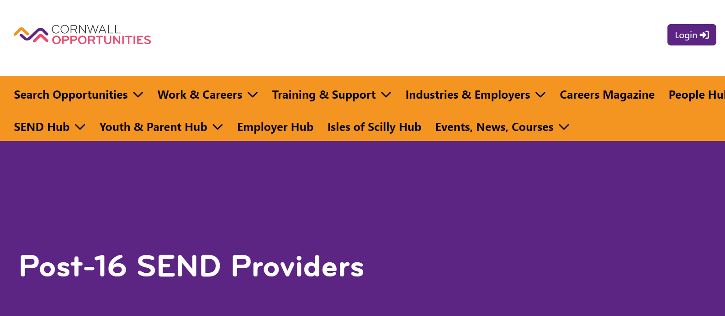  Link through our website using the following tabs:  - Parents  - Post 16 and Beyond  - Provision After Curnow | Start to make enquiries:  Not all providers can cater for all needs – we have put together a few keys questions you might find useful  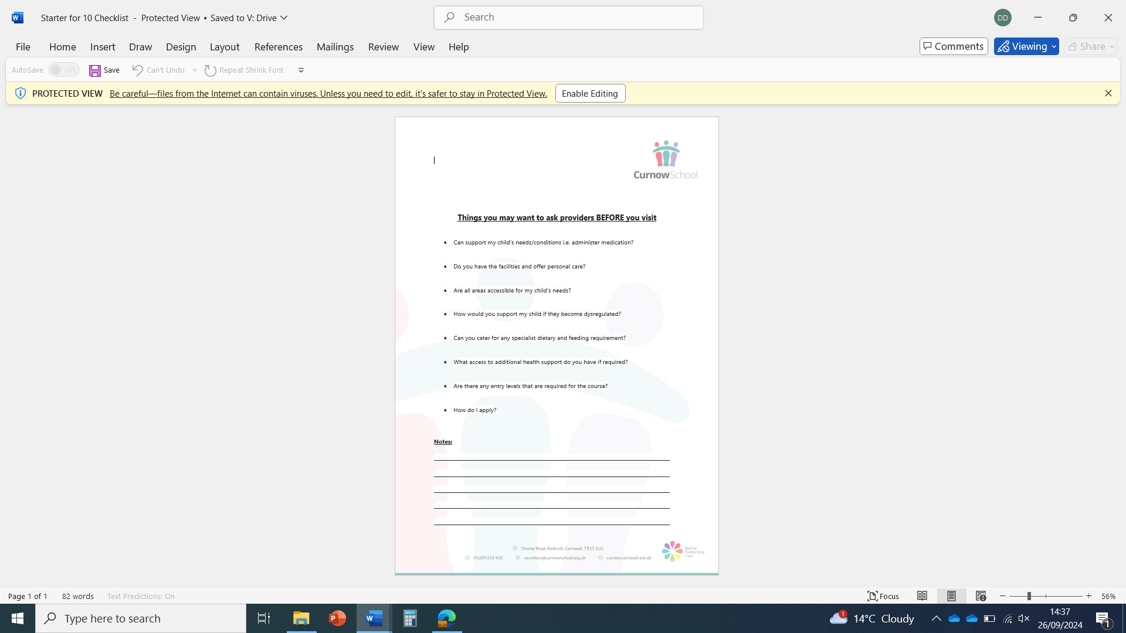
Year 2 (Y13) | Book your visits:  Go and see as many providers as you can to inform choice | Narrow it down:  Book 2nd visits to your top choices and maybe at a different time of the day – visit the classrooms, dining hall, outside | Make your choice:  Meet with CSW to complete paperwork to inform county of your choice(s)  Contact Details on our ‘Post 16 and Beyond’ web page
Year 3 (Y14) | Over to us:  Once confirmed, we contact the chosen setting to open up lines of communication to begin to discuss transition timings…expectations etc | Transition begins:  We work with the new setting to set up visits to them or if more appropriate invite their staff to come to us to meet the young person in our setting to get to know them | Transition visits  If they haven’t happened already – visits to the new setting will be take place

